**Project Part 4a - 30 points total**

At this point your report should have a title page, a proposal which summarizes your project and network architecture, and descriptions of your entities and attributes. Your GitHub should have your ERD file and 10 data files containing 3 entries each for 5 entities in both CSV and XML format.   
  
Next your project will exercise your use of SQL commands by requiring you to create databases, load your data files into the databases, and then perform a few exercises. Finally, address the thought exercise at the end.

**TO GET CREDIT:**

**1.** Take screen captures of the results to prove that your command did what it needed to do. More specifically, show a ‘before” picture, then an ‘after’ picture with your command in the middle. A simple status message of ‘ok’ is NOT acceptable.   
  
**2.** Perform these actions EITHER on MariaDB in Linux, OR in XAMPP. Remember, I need to test these commands.

**Also, INDICATE in your report which system you used.**

**3.** Include part of your desktop as evidence that you did this work yourself. For example, here is one I might do:

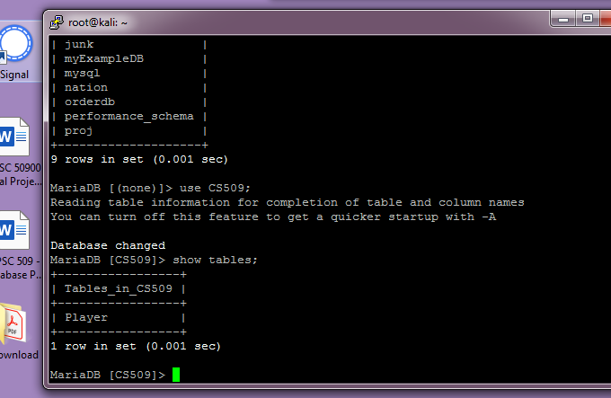

It isn’t a real ‘before/after’ example, but it shows data before I issued a command, it shows the command, and then it shows the results afterward. You can also see my desktop off to the side, and expect to see it in all future screen captures. **This is the model for what your screen captures should look like**.

**Data Definition Language Scripts**

For this segment of the project you must write SQL commands to create your database tables and then load your data files into your tables. When you are finished, your database tables should contain all of the information that you described in your XML or CSV data sources. You may choose which 5 files you wish to load. I just need to see the script and the populated tables.

**Document** your work in your **report** by showing the screen captures of the results.

The screen captures must show the contents of the database matching your design and the contents of your data files.

Also, save your scripts (table creation and loading command) to a text file that ends with the .sql extension, and save your script files to GitHub. Your data files should already be in GitHub so I can test them.

**Tips to load your data files**

Now that you have the tables created, you must complete this section by loading your data files with a ‘load’ command.

TO IMPORT DATA INTO MariaDB:

1. Use “LOAD DATA LOCAL INFILE ‘filename’ “ to load a delimited Excel file (usually a comma separated value, CSV).

<https://mariadb.com/kb/en/load-data-infile/>

This will also work if you use XAMPP.

2. If you are using XML files to store data, then see this example:

<https://mariadb.com/kb/en/load-xml/>

Again, a single command will load the contents of your file.   
  
If you get an error like the file is missing, then you need to either find the active directory and copy the data files there, or else include the absolute path to your files as part of the file name when you do the ‘load’. You probably need the ‘LOCAL’ option also.

Example:  
#> LOAD DATA LOCAL INFILE ‘/home/matt/cs509/products.CSV’

**See the requirements and scoring on the next page.**

**Requirements (read all 3 before starting)**

1. Create the SQL script for creating your data tables. You should have 1 table per entity for a total of 5 tables. You can either write this in one script or split your work into 5 small scripts. Save and submit script(s) to your github.

2. Create the SQL script to load your data files into your tables. Again, you may split up your script. Save and submit your work to your github.

3. Take screen captures of your data tables that show they are empty. I only need one screen, so if you can only fit two or three tables to a screen, that’s fine. Then take a screen capture of the load command after it successfully executes. Then finally take a screen capture of the same tables populated with data.

Again, I only need ONE screenshot of each step. Show at least two tables in your screenshots.

**Rubric**

* SQL script that creates your tables saved as an sql script file (this is a simple text file with a .sql extention). Upload to GitHub. 10 points
* SQL script that loads your data files to your tables, also saved in an sql script file. 10 points
* Screenshots of your populated tables with at least three records from your data files: 10 points  
  The ‘before’ picture shows an empty table.   
  Note: I don’t need a screen shot of the creation of the table because that would be redundant.

Total points possible: 30